The Truth Behind the Mist: The Harm of Etomidate and E-Cigarettes

If you could live your life again…
Would you spend your money, your health,
and your beauty on smoking and drugs?
Some people say smoking and drugs are not addictive.
Do you believe that?

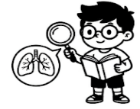

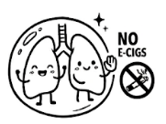

Task 1: Poison in Disguise ─ Identifying Smoking Products

Matching: Do you know their names?
 | 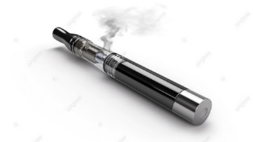 | 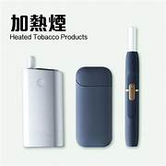
Addictive / Not Addictive | Addictive / Not Addictive | Addictive / Not Addictive
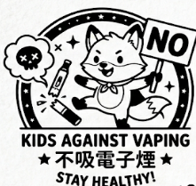
Task 2: Drug Delivery Devices ─ Understanding the Harm of E-cigarettes
Please circle the correct answer:
- E-cigarettes that have become drug carriers. Cannabis and etomidate can be injected into vape pods. Users cannot / can tell from the appearance whether these cigarettes are problematic.
- Buying through face-to-face / online makes it easier to obtain cigarettes with drugs.
- Pods come in various flavours, the sugar-coated packaging makes them more / less covert and harder for you to detect.

Task 3: Understand e-cigarette laws
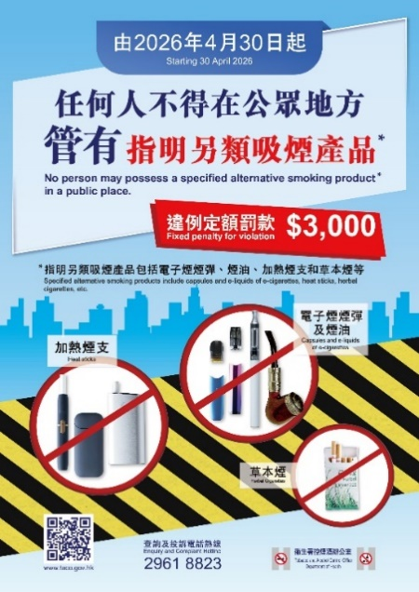
Please read the poster and circle the correct answers on the new e-cigarette laws:
Starting from (April 30, 2026 /
April 30, 2027), the provisions relating
to alternative smoking products under the Tobacco Control Legislation (Amendment) Ordinance 2025 officially came into effect.
No person may possess (vape pods, e-liquid, heated tobacco sticks, herbal cigarettes), or other alternative smoking substances in (public places / private places). Even if they are only (carried / inactivated and have not actually been used), this will still be regarded as
an offence.

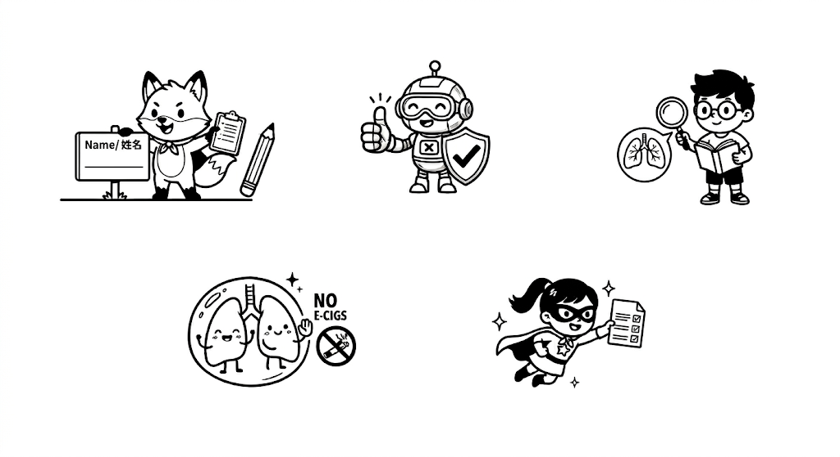
Conclusion: If you could live your life again…
Would you try your first cigarette? Yes / No
The path you take is your choice—stay away from e-cigarettes.
The Truth Behind the Mist: The Harm of Etomidate and E-Cigarettes
Smoke Out the Truth: VAPING WILL POISON AND KILL YOU!
If you could live your life again…
Would you spend your money, your health,
and your beauty on smoking and drugs?
Some people say smoking and drugs are not addictive.
Do you believe that?

Task 1: Poison in Disguise ─ Identifying Smoking Products
Matching: Do you know their names?
Herbal Cigarettes | E-cigarettes | Heated Tobacco Products
Addictive / Not Addictive | Addictive / Not Addictive | Addictive / Not Addictive
Task 2: Drug Delivery Devices ─ Understanding the Harm of E-cigarettes
Please circle the correct answer:
- E-cigarettes that have become drug carriers. Cannabis and etomidate can be injected into vape pods. Users cannot tell from the appearance whether these cigarettes are problematic.
- Buying through online makes it easier to obtain cigarettes with drugs.
- Pods come in various flavours, the sugar-coated packaging makes them more covert and harder for you to detect.

Task 3: Understand e-cigarette laws
Please circle the correct answers from the poster on the new e-cigarette laws:
Starting from April 30, 2026, the provisions relating to alternative smoking products under the Tobacco Control Legislation (Amendment) Ordinance 2025 officially came into effect.
No person may possess vape pods, e-liquid, heated tobacco sticks, herbal cigarettes, or other alternative smoking substances in public place. Even if they are only carried/inactivated and have not actually been use), this will still be regarded as illegal / an offence.

The path you take is your choice—stay away from e-cigarettes.
Conclusion: If you could live your life again…
Would you try your first cigarette? Yes / No

