The Truth Behind the Mist: The Harm of Etomidate and E-Cigarettes

📢 [Introduction]

To prevent criminals from using misleading claims such as “harm reduction” and “being trendy” to attract the youth trying alternative smoking products, the Government amended the Smoking Ordinance on 30 April 2026 to close regulatory loopholes. As a new-generation cyber defender, please complete the following system testing and upgrade your defensive network!

🎯 Task 1: Poison in disguise ─ Identifying Smoking Products

Do you know their names? Match them correctly:
E-cigarettes, Herbal Cigarettes, and Heated Tobacco Products.
Will using them lead to addiction? Circle the correct answer.

A. | B. | C.
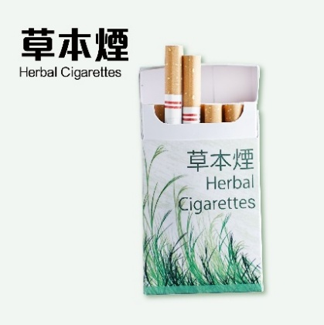 | 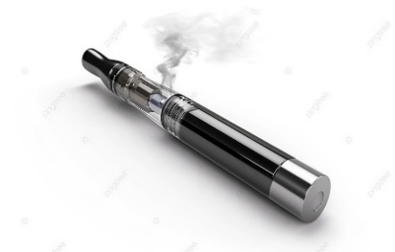 | 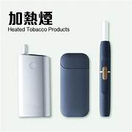
Addictive / Not Addictive | Addictive / Not Addictive | Addictive / Not Addictive

☣️ Task 2: Drug Delivery Devices ─ Understanding the Harm of E-cigarettes
Fill in the correct words to unfold the hidden tactics used by drug dealers.

1.Smoking is not just smoking E-cigarettes that have become [_______________] carriers. [_______________] and [_______________] can be injected into vape pods. You think you're just smoking, but you may be taking drugs.

2.Difficult to identify: Being identical in appearance and without the pungent smell of traditional drugs, the [_______________] makes them more covert and harder for you to detect.

3.Easy to buy: Buying "laced cigarettes" [_______________] may seem to be convenient, but it can unwittingly trap you in [_______________], plunging you into an inescapable drug abyss.
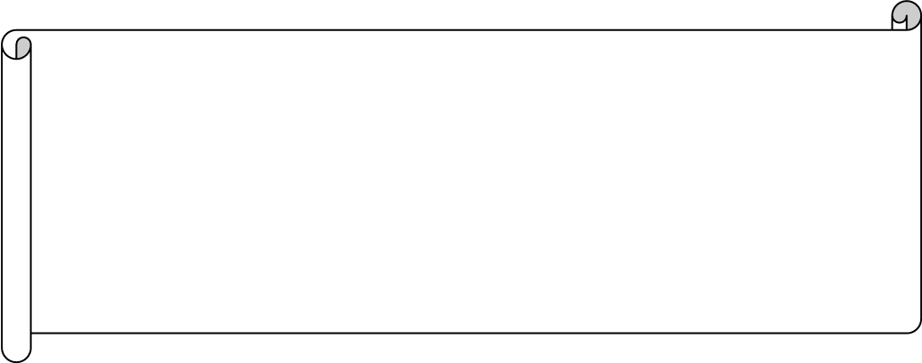
🛡️ Task 3: Closing Loopholes: Government Action Against Alternative Smoking Products
Starting from [_________], the provisions relating to alternative smoking products under the Tobacco Control Legislation (Amendment) Ordinance 2025 officially came into effect.
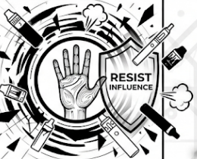
No person may possess vape pods, e-liquid, heated tobacco sticks, herbal cigarettes, or other alternative smoking substances in [_______________]. Even if they are only [_______________] and have not actually been used, this will still be regarded as possession and [_______________]. Offenders are subject to a fixed penalty of $[___________].

⚠️ Task 4: Cost Estimation: The Price of Vaping
Write down the possible consequences of using e-cigarettes.

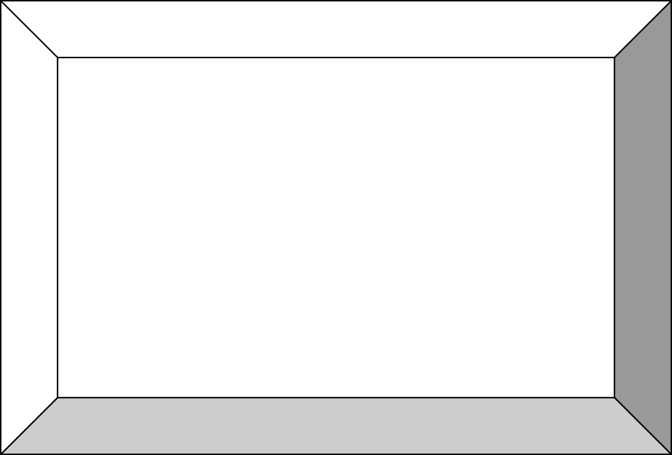

“I Choose My Own Path”
Stay Away from E-cigarettes. Do Not Become the Next Headline.



The Truth Behind the Mist: The Harm of Etomidate and E-Cigarettes

📢 [Introduction]

To prevent criminals from using misleading claims such as “harm reduction” and “being trendy” to attract the youth trying alternative smoking products, the Government amended the Smoking Ordinance on 30 April 2026 to close regulatory loopholes. As a new-generation cyber defender, please complete the following system testing and upgrade your defensive network!

🎯 Task 1: Poison in disguise ─ Identifying Smoking Products

Do you know their names? Match them correctly:
E-cigarettes, Herbal Cigarettes, and Heated Tobacco Products.
Will using them lead to addiction? Circle the correct answer.

A. Herbal Cigarettes | B. E-cigarettes | C. Heated Tobacco Products
Addictive / Not Addictive | Addictive / Not Addictive | Addictive / Not Addictive

☣️ Task 2: Drug Delivery Devices ─ Understanding the Harm of E-cigarettes
Fill in the correct words to unfold the hidden tactics used by drug dealers.
1. Smoking is not just smoking E-cigarettes that have become [____drug_____] carriers. [____Cannabis_____] and [___etomidate____] can be injected into vape pods. You think you're just smoking, but you may be taking drugs.

2. Difficult to identify: Being identical in appearance and without the pungent smell of traditional drugs, the [____sugar-coated packaging____] makes them more covert and harder for you to detect.

3. Easy to buy: Buying "laced cigarettes" [____online_____] may seem to be convenient, but it can unwittingly trap you in [___drug addiction____], plunging you into an inescapable drug abyss.

🛡️ Task 3: Closing Loopholes: Government Action Against Alternative Smoking Products
Starting from [April 30, 2026], the provisions relating to alternative smoking products under the Tobacco Control Legislation (Amendment) Ordinance 2025 officially came into effect.
No person may possess vape pods, e-liquid, heated tobacco sticks, herbal cigarettes, or other alternative smoking substances in [public places]. Even if they are only [carried / inactivated] and have not actually been used, this will still be regarded as possession and [illegal / an offence]. Offenders are subject to a fixed penalty of $[3000].

⚠️ Task 4: Cost Estimation: The Price of Vaping
Write down the possible consequences of using e-cigarettes.

[Suggested Answers]
- Violating the law:
- Ruining your health:
- Wrecking your future:
- And more…

“I Choose My Own Path”
Stay Away from E-cigarettes. Do Not Become the Next Headline.

