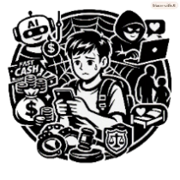
Unmasking the Screen: Deconstructing Online Sexual Grooming

📢Introduction
The online world is fun. You can meet new friends and share your daily life. However, not everyone online can be trusted.
Become an Online Safety Detective! Complete the following tasks and learn how to protect yourself online.

🎯Task 1: Self-Check — My Use of Online Media
Please complete the following questions based on your own situation.
- Do I use these platforms？
If you use any of the following social-media or online platforms, put a tick (✓) in the box.
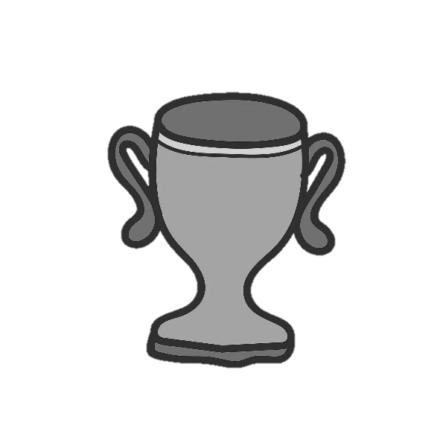
Instagram WeChat Video platform (For example: YouTube)
Online games Other: _________________

- Which platforms do I use most often?
Write down the three platforms that you use most often.
🥇Most used: __________________
🥈2nd most used: __________________
🥉3rd most used: __________________

- Have I encountered suspicious situations?
When using social media or online platforms, have you ever experienced any of the following? Please place a tick "✓" in the box.

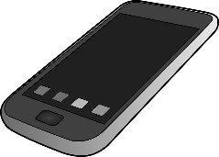
- Received messages from strangers
- Strangers reached out wanting to be friends with you
- Experienced a situation that felt strange or uncomfortable
- None of the above

🔎Task 2: Protect My Boundaries
In the video, Nam asks Tung to wear a swimsuit for filming. If you were Tung, what would you say when someone asks you to do something that makes you feel uncomfortable?
💡Suggestion: Use the three-step “I-Message” method:

💬Say what happened
“When you ask me to_____________________________________”
❤️Say how you feel
“I feel____________________________________________”
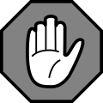
🛑Set a clear boundary
Fill in the circle (●) next to the response you would use.
○ I do not want to do that.
○ I am not comfortable with this request.
○ I would like us to do something else.
○ Please respect my decision.”
○ Other: ___________________________________________

🛡️Task 3: Three Steps to Stay Safe
Read what the three students say. Fill in the circle (●) next to the safe choice.

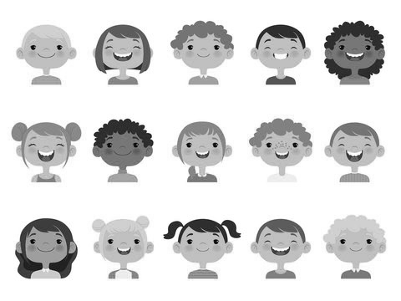
🛑 Say No to Inappropriate Requests
○ If a good friend asks me to do something,
I should agree to every request.
○ If a request makes me feel uncomfortable,
I can bravely say “No”.

🔒Protect my Personal Information
○ I will not casually tell strangers my name, school or home address.
○ If an online friend asks, I can tell them my personal information.

🗺️ Make Safe Meeting Plans
○ If I meet an online friend, I will choose a busy public place.
○ I will l

Unmasking the Screen: Deconstructing Online Sexual Grooming

📢Introduction
The online world is fun. You can meet new friends and share your daily life. However, not everyone online can be trusted.
Become an Online Safety Detective! Complete the following tasks and learn how to protect yourself online.

🎯Task 1: Self-Check — My Use of Online Media
Please complete the following questions based on your own situation.
- Do I use these platforms？
If you use any of the following social-media or online platforms, put a tick (✓) in the box.
Instagram WeChat Video platform (For example: YouTube)
Online games Other: _________________

- Which platforms do I use most often?
Write down the three platforms that you use most often.
🥇Most used: __________________
🥈2nd most used: __________________
🥉3rd most used: __________________

- Have I encountered suspicious situations?
When using social media or online platforms, have you ever experienced any of the following? Please place a tick "✓" in the box.

- Received messages from strangers
- Strangers reached out wanting to be friends with you
- Experienced a situation that felt strange or uncomfortable
- None of the above

🔎Task 2: Protect My Boundaries
In the video, Nam asks Tung to wear a swimsuit for filming. If you were Tung, what would you say when someone asks you to do something that makes you feel uncomfortable?
💡Suggestion: Use the three-step “I-Message” method:

💬Say what happened
“When you ask me to_____________________________________”
❤️Say how you feel
“I feel____________________________________________”
🛑Set a clear boundary
Fill in the circle (●) next to the response you would use.
○ I do not want to do that.
○ I am not comfortable with this request.
○ I would like us to do something else.
○ Please respect my decision.”
○ Other: ___________________________________________

🛡️Task 3: Three Steps to Stay Safe
Read what the three students say. Fill in the circle (●) next to the safe choice.

🛑 Say No to Inappropriate Requests
○ If a good friend asks me to do something,
I should agree to every request.
○ If a request makes me feel uncomfortable,
I can bravely say “No”.

🔒Protect my Personal Information
○ I will not casually tell strangers my name, school or home address.
○ If an online friend asks, I can tell them my personal information.

🗺️ Make Safe Meeting Plans
○ If I meet an online friend, I will choose a busy public place.
○ I will let the other person arrange everything and pick me up.

et the other person arrange everything and pick me up.

