Spotting Quick Cash Traps: Say No to Temptation

Task 1
I was only helping to collect money, open a bank account or run errands. I was not the one who cheated anyone, so the punishment should not be serious, right? ✔/✘
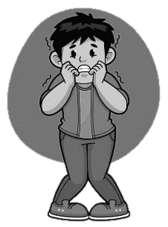

Legal Consequences：
- Theft: Maximum penalty of [ 3 / 10] years' imprisonment.
- Fraud: Upon conviction, maximum penalty of [ 8 / 14] years' imprisonment.
- Money Laundering: Lending a bank account to others or helping to handle proceeds of crime may result in a maximum penalty of HK of [ HK$500,000 / HK$5,000,000] and of [ 8 / 14 ] years' imprisonment.

Task 2


When we see part-time job advertisements online, or hear from friends about jobs that claim “Earn thousands of dollars a day”, “No experience needed” or “Instant payment”, how can we spot illegal activities?
Mysterious Rewards
Demanding Secrecy

Strange Tasks
Asking for Private Passwords
Unfair Exchanges

My Pledge



Signature:

Spotting Quick Cash Traps: Say No to Temptation

Task 1
I was only helping to collect money, open a bank account or run errands. I was not the one who cheated anyone, so the punishment should not be serious, right? ✔/✘

Legal Consequences：
- Theft: Maximum penalty of __10___ years' imprisonment.
- Fraud: Upon conviction, maximum penalty of _14____ years' imprisonment.
- Money Laundering: Lending a bank account to others or helping to handle proceeds of crime may result in a maximum penalty of HK$__5,000,000___ and __14___ years' imprisonment.

Task 2

When we see part-time job advertisements online, or hear from friends about jobs that claim “Earn thousands of dollars a day”, “No experience needed” or “Instant payment”, how can we spot illegal activities?
Mysterious Rewards
Demanding Secrecy
Strange Tasks
Asking for Private Passwords
Unfair Exchanges

My Pledge

Signature:

